**Website Design Brief for Sav-e**

**Introduction and Project Objectives**

*‘Sav-e scans receipts to track your spending and earn rewards.’*

Sav-e’s’ purpose is to enable users to track their spending through the simple task of scanning receipts and also earn rewards to redeem vouchers or prizes by doing other tasks such as answering surveys.

Sav-e is a start-up formed by Kantar Worldpanel, a company dealing with consumer knowledge and insights based on consumer panels. The consumer panel currently covers 30,000 households in the UK, though Kantar Worldpanel would like to improve its panel quality by reaching a larger audience. Expanding the panel is very costly for the company, however Sav-e will allow Kantar Worldpanel to reach an unlimited amount of shoppers with less incentives needed as the user of the app will benefit from the task itself and therefore less rewards are required.

We require a website that mimics the functionality of our app (currently in development) for proof of concept. The app provides users the ability to scan their shopping receipts to monitor their spending behaviour and also gain rewards by doing additional tasks.  
  
We envisage there being approx 20-25 screens/pages required for the test site to operate correctly.

The site will look include:

* Add Receipt – incl. Camera Function & Manual Input
* View Spending – incl. Main category spend & Receipt Detail
* Rewards – incl. Reward Balance, Redeem & Earn Points (through tasks)
* Transaction History – incl. List of receipts and receipt detail
* Profile – Name, email, DOB, postcode, gender, salary

**Target Audience Market**

The target is people who wants to track their spending and save money, but initially aimed at young professionals looking to save money.

i.e *Joe – 27, lives in London and is trying to save to buy a house but doesn’t know where his money goes.*

**Competitors**

Our nearest competitors are:-

* Monzo
* Excel
* Banking Apps

**Requirement of the new Site**

* To test the user journey by enabling users to fulfil all objectives of the site and its main tasks – this will enable us to understand whether the flow of the app makes sense to the consumer and whether any changes need to be made.
* To understand whether the scanning receipt or manual entry functions are simple enough that the users will continue to use the app on a daily basis
* To understand if the categories make sense to the user or whether these should include different categories to suit people’s needs
* To understand whether there are any gaps in the information we are providing – is there anything the users feel they are not fed back through the app

**Priority**

**First Release**

* Sign Up
* Add receipt – Camera / Manual Entry
* View Transactions

**Second Release**

* View Spending – main category detail
* Rewards 1
* Profile Page

**Third Release**

* View spending – category items & receipt detail
* Rewards – reward items and details (surveys) 2/3
* Transactions – view receipt

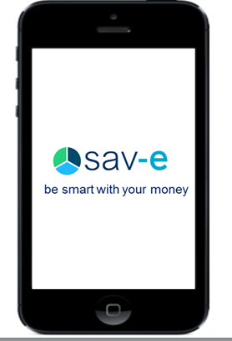

3.    Sign Up clicks to Walkthrough pages, which then goes to Home Screen (Add Receipt) – need images from Ola

4.    Add Receipt goes to the fake capture screen (GET RID OF THE PINK BUTTON FOR A BLACK ONE) and then when you click on the circle, it takes you back to Add receipt page.

8.    OVERLAY - Once you Add receipt on Camera – there is an overlay that says “Are you happy with your Snap?” Options – “No, take again” “Yes, I’m Happy” – which goes to a second overlay that says “Scan successful” and then you click ok below.

9.    OVERLAY – Once you Redeem a reward, it says “Redeem Successful” and then you click OK below. - done

10.  (Needs to be looked at) Store selection field on Manual entry, type prediction in the drop down box. It works already? done